Unit-V
Performing User Interface Design
User interface design creates an effective communication medium between a human and a computer
The design should be easy to learn, easy to use & easy to understand.
Typical Design Errors
Lack of consistency
Too much memorization
No guidance / help
No context sensitivity
Poor response
unfriendly
4.1 The Golden Rules
Theo Mandel coins three gold rules
- Place the user in control
- Reduce the user’s memory load
- Make the interface consistent
4.1.1 Place the user in control
- Define interaction modes in a way that does not force a user into unnecessary or undesired actions: An interaction mode is current state of interface. For ex if spell check is selected in a word processor menu, the software moves to a spell checking mode .There is no reason to force the user to remain in spell check mode if the user desires to make text editing.
- Provide for flexible interaction: Software might allow a user to interact via keyboard commands, mouse movements, digitizer pen, voice commands etc.Every action is not amenable to every interaction mechanism.Consider, the difficulty of using key board commands (or voice input) to draw a complex shape.
- Allow user interaction to be interruptible and undoable: Even when involved in sequence of actions the user should be able to interrupt the sequence. The user should be able to undo any action.
- Streamline interaction as skill levels advance and allow the interaction to be customized : Design a macro mechanism that enables an advanced user to customize the interface to facilitate interaction
- Hide technical internals from the casual user. The user should not be aware of operating system, file management functions, or other computing technology.
- Design for direct interaction with objects that appear on the screen: The user must be able to manipulate the objects when necessary. For ex an interface that allows a user to stretch an object is an implementation of direct manipulation.
4.1.2 Reduce the Users Memory Load
- Reduce demand on short-term memory: The interface should be designed to reduce requirement to remember past actions and results. This can be accomplished by providing visual clues that enables a user to recognize past actions and results, rather than having to recall them
- Establish meaningful defaults : The initial set of defaults should make sense for avg user, but a user should be able to specify individual preferences
- Define shortcuts that are intuitive :When mnemonics are used to accomplish a system function, the mnemonic should be tied to action in a way that is easy to remember.(For ex ALT-P to invoke print function)
- The visual layout of the interface should be based on a real world metaphor :
For ex a bill payment system should use a checkbook and check register to guide through bill paying process.
- Disclose information in a progressive fashion: The interface shall be organized hierarchically. For ex underline in word processor is in text style menu. After selecting underline many underline options are presented.
4.1.3 Make the Interface Consistent
- Allow the user to put the current task into a meaningful context. Many interfaces implement complex layers of interactions with dozens of screen images. It is important to provide indicators (e.g., window titles, graphical icons, consistent color-coding) that enable the user to know the context of the work at hand.
- Maintain consistency across a family of applications. A set of applications (or products) should all implement the same design rules so that consistency is maintained for all interaction.
- If past interactive models have created user expectations, do not make changes unless there is a compelling reason to do so. Once a particular interactive sequence has become a de facto standard (e.g., the use of alt-S to save a ﬁle), the user expects this in every application he encounters. A change (e.g., using alt-S to invoke scaling) will cause confusion.

4.2 User Interface Analysis and Design
- The overall process for analyzing and designing a user interface begins with the creation of different models of system function.
- The human and computer-oriented tasks that are required to achieve system function are then delineated; design issues that apply to all interface designs are considered; are and the result is evaluated for quality
4.2.1Interface Analysis & Design Models
- There are 4 different models that is to be considered when a user interface is to be analyzed and designed.

- User model Establishes a profile of all end users of the system
Users can be categorized as
1. Novice – No syntactic knowledge of the system and little semantic knowledge of the application or computer usage of the system
2. Knowledgeable, intermittent users- Reasonable semantic knowledge of the application but low recall of syntactic information to use the system
3. Knowledgeable, frequent users-Good semantic and syntactic knowledge

- Design model A design model of the entire system incorporates data,architectural,interface and procedural representation of the software
A design realization of the user model
- User’s Mental model (system perception) the user’s mental image of what the interface is
- Implementation model the interface “look and feel” coupled with supporting information that describe interface syntax and semantics
When the implementation model and user’s mental model coincide, users generally feel comfortable with the software and use it effectively.
4.2.2User interface analysis and design process
- The user interface analysis and design process is an iterative process and it can be represented as a spiral model
- It consists of 4 framework activities
1. User, task and environment analysis
2. Interface design
3. Interface construction
4. Interface validation
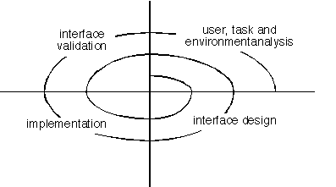
Interface analysis
-Understanding the user who interacts with the system based on their skill levels.
-The task the user performs to accomplish the goals of the system are identified, described and elaborated.
Interface design
In interface design, all interface objects and actions that enable a user to perform all desired task are defined
Implementation
A prototype is initially constructed and then later user interface development tools may be used to complete the construction of the interface.
Validation
The correctness of the system is validated against the user requirement

4.3 Interface Analysis
- Interface analysis means understanding
(1) the people (end-users) who will interact with the system through the interface;
(2) the tasks that end-users must perform to do their work,
(3) the content that is presented as part of the interface
(4) the environment in which these tasks will be conducted.
4.3.1User Analysis
The ways to learn what the users want from UI?
User Interviews: Interviews involve representatives from software team who meet with end-users to better understand their needs
Sales Input: Sales people meet with customers and users on regular basis and gather information that will help software team to categorize users.
Support Input : Support staff talk with users on daily basis
- The following set of questions will help interface designers better understand the users of a system. Are users trained professionals, technician, clerical, or manufacturing workers?
- What level of formal education does the average user have?
- Are the users capable of learning from written materials or have they expressed a desire for classroom training?
- Are users expert typists or keyboard phobic?
- What is the age range of the user community?
- Will the users be represented predominately by one gender?
- How are users compensated for the work they perform?
- Do users work normal office hours or do they work until the job is done?
- What is the primary spoken language among users?
- What are the consequences if a user makes a mistake using the system?
- Are users experts in the subject matter that is addressed by the system?
- Do users want to know about the technology the sits behind the interface?

4.3.2Task Analysis and Modelling

The goal of task analysis is to answer the following questions.
  - What work will the user perform in specific circumstances?
  - What tasks and subtasks will be performed as the user does the work?
  - What specific problem domain objects will the user manipulate as work is performed?
  - What is the sequence of work tasks—the workflow?
  - What is the hierarchy of tasks?
Analysis Techniques
- Use-cases define basic interaction.When used as part of task analysis the use-case is developed to show how an end-user performs some specific work-related task.
- Task elaboration refines interactive tasks
Regardless of the overall approach to task analysis, a human engineer must ﬁrst deﬁne and classify tasks.
For example, assume that a small software company wants to build a computer-aided design system explicitly for interior designers. By observing an interior designer at work, the engineer notices that interior design comprises a number of major activities: furniture layout, fabric and material selection, wall and window coverings selection, presentation (to the customer), costing, and shopping. Each of these major tasks can be elaborated into subtasks. For example, furniture layout can be reﬁned into the following tasks: (1) draw a ﬂoor plan based on room dimensions;2) place windows and doors at appropriate locations; (3) use furniture templates to draw scaled furniture outlines on ﬂoor plan; (4) move furniture outlines to get best placement; (5) label all furniture outlines; (6) draw dimensions to show location; (7)raw perspective view for customer.
Subtasks 1–7 can each be reﬁned further.
- Object elaboration identifies interface objects (classes)
For ex the furniture template might translate into a class called Furniture with attributes that might include size, shape, location and others.
- Workflow analysis defines how a work process is completed when several people (and roles) are involved
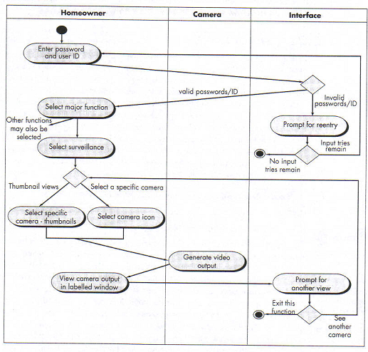

4.3.3.Analysis Of Display Content
During this interface analysis step,the format and aesthetics of the content are considered.Among the questions that are asked and answered are
- Are different types of data assigned to consistent geographic locations on the screen (e.g., photos always appear in the upper right hand corner)?
- Can the user customize the screen location for content?
- Is proper on-screen identification assigned to all content?
- If a large report is to be presented, how should it be partitioned for ease of understanding?
- Will mechanisms be available for moving directly to summary information for large collections of data.
- Will graphical output be scaled to fit within the bounds of the display device that is used?
- How will color to be used to enhance understanding?
- How will error messages and warning be presented to the user?
4.3.4Analysis of work environment
-Analysis of work environment focuses on
- Where will the interface be located physically?
• Will the user be sitting, standing, or performing other tasks unrelated to the interface?
• Does the interface hardware accommodate space, light, or noise constraints?
• Are there special human factors considerations driven by environmental factors?
4.4 Interface Design Steps
Once interface analysis has been completed, all tasks required by the end-user have been identified in detail, and the interface design activity commences. Interface design, like all software engineering design, is an iterative process.
Although many different user interface design models have been proposed, all suggest some combination of following steps
- Using information developed during interface analysis define interface objects and actions (operations).
- Define events (user actions) that will cause the state of the user interface to change. Model this behavior.
- Depict each interface state as it will actually look to the end-user.
- Indicate how the user interprets the state of the system from information provided through the interface.
4.4.1Applying Interface Design Steps
An important step in interface design is definition of interface objects & actions that are applied to them. Nouns (objects) & Verbs (actions) are isolated to create list of objects & actions.
Once objects&actions have been identified, they are categorized by type.
Target, source & application objects. A source object (report) is dragged & dropped into a target object (print).The implication of this action is to create a hard-copy report.
An application Object represents application specific data that are not directly manipulated as part of screen interaction (Ex a mailing list store name of mailing list itself maight be sorted,merged,but it is not dragged & dropped via user interaction)
When designer is satisfied that all important objects & actions have been identified, screenlayout is performed. Screen layout is an iterative process in which graphical design & placement of icons, tiling of windows, and definition of major & minor menu items is conducted.
4.4.2Interface Design Patterns
Patterns are available for
The complete UI, Page layout, Forms and input, Tables, Direct data manipulation, Navigation,
Searching, pageelements &e-commerce.
4.4.3Design Issues
- Response time
- Help facilities
- Error handling
- Menu and command labeling
- Application accessibility
- Internationalization
Response time: System response time is the primary complaint for many interactive applications. In general, system response time is measured from the point at which the user performs some control action (e.g., hits the return key or clicks a mouse) until the software responds with desired output or action.
System response time has two important characteristics: length and variability.
the length of system response is too long, user frustration and stress is the inevitable.
Variability refers to the deviation from average response time, and in many ways, it is the most important response time characteristic. Low variability enables the user to establish an interaction rhythm, even if response time is relatively long. For example, a 1-second response to a command is preferable to a response that varies from 0.1 to 2.5 seconds.
Help facilities: Almost every user of an interactive, computer-based system requires help now and then. However, modern software provides on-line help facilities that enable a user to get a question answered or resolve a problem without leaving the interface.
Two different types of help facilities are encountered: integrated and add-on
An integrated help facility is designed into the software from the beginning.
An add-on help facility is added to the software after the system has been built.
A number of design issues must be addressed when a help facility is considered:
• Will help be available for all system functions and at all times during system interaction?
• How will the user request help?
• How will help be represented?
• How will the user return to normal interaction?
• How will help information be structured?
Error handling : Error messages and warnings are "bad news" delivered to users of interactive systems when something has gone awry. here are few computer users who have not encountered an error of the form:
SEVERE SYSTEM FAILURE -- 14A
Somewhere, an explanation for error 14A must exist; otherwise, why would the designers have added the identiﬁcation? Yet, the error message provides no real indication of what is wrong.Such type of messages turn user into frustration & anxiety.
In general, every error message or warning produced by an interactive system should have the following characteristics:
• The message should describe the problem in jargon that the user can understand.
• The message should provide constructive advice for recovering from the error.
• The message should indicate any negative consequences of the error (e.g.,potentially corrupted data ﬁles) so that the user can check to ensure that theyhave not occurred (or correct them if they have).
• The message should be accompanied by an audible or visual cue. That is, a beep might be generated to accompany the display of the message, or the message might ﬂash momentarily or be displayed in a color that is easily recognizable as the "error color."
• The message should be "nonjudgmental." That is, the wording should never place blame on the user
Menu and command labeling : the typed command was once the most common mode of interaction between user and system software and was commonly used for applications of every type.
A number of design issues arise when typed commands are provided as a mode of interaction:
• Will every menu option have a corresponding command?
• What form will commands take? Options include a control sequence (e.g.,alt-P), function keys, or a typed word.
• How difﬁcult will it be to learn and remember the commands? What can be done if a command is forgotten?
• Can commands be customized or abbreviated by the user?
Application accessibility
As computing applications become ubiquitous, software engineers must ensure that interface design encompasses mechanisms that enable easy access for those with special needs. Accessibility for users who may be physically challenged is an imperative for moral, legal and business reasons
Internationalization
Too often interfaces are designed for one locale and language and then jury-rigged to work in other countries. The challenge for interface designers is to create globalized software. Varieties of international guidelines are available to software engineers. These guidelines address broad design issues (ex screen layouts) and discrete implementation issues (ex different alphabets create specialized labeling and spacing requirements).
4.5 Design Evaluation
Once an operational user interface prototype has been created, it must be evaluated to determine whether it meets the needs of the user.
The user interface evaluation cycle takes the form shown in Figure 15.3. After the design model has been completed, a first-level prototype is created. The prototype is evaluated by the user, who provides the designer with direct comments about the efficacy of the interface. Design modifications are made based on user input and the next level prototype is created. The evaluation cycle continues until no further modiﬁcations to the interface design are necessary.
Once the first prototype is built, the designer can collect a variety of qualitative and quantitative data that will assist in evaluating the interface. To collect qualitative data, questionnaires can be distributed to users of the prototype. Questions can be all (1) simple yes/no response, (2) numeric response, (3) scaled (subjective) response, or (4) percentage (subjective) response.
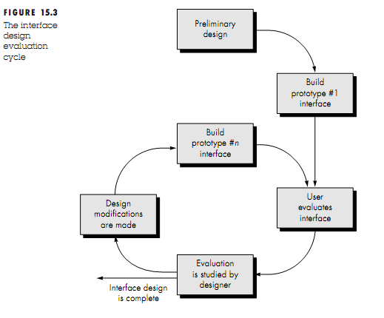

Object-Oriented Design
An object-oriented system is made up of interacting objects that maintain their own local state and provide operations on that state
Object-oriented design processes involve designing object classes and the relationships between these classes.
Object-oriented design is part of object-oriented development where an object-oriented strategy is used throughout the development process:
- OOA is concerned with developing an object model of the application domain.
- OOD is concerned with developing an object-oriented system model to implement requirements.
- OOP is concerned with realising an OOD using an OO programming language such as Java or C++.
Characteristics of OOD
- Objects are abstractions of real-world or system entities and manage themselves.
- Objects are independent
- System functionality is expressed in terms of object services.
- Objects communicate by message passing.
- Objects may be distributed and may execute sequentially or in parallel
Advantages of OOD
- Easier maintenance. Objects may be understood as stand-alone entities.
- Objects are potentially reusable components
  - Objects & Object Classes

Object: An object is an entity that has a state and a defined set of operations that operate on that state. The state is represented as a set of object attributes. The operations associated with the object provide services to other objects (clients) which request these services when some computation is required.
Object class: Object classes are templates for objects. They are used to create objects. It includes declaration of all the attributes and operations that are associated with object of that class.
In the UML, an object class is represented as a named rectangle with two sections. The object attributes are listed in the top section. The operations that are associated with the object are set out in the bottom section. Figure 14.2 illustrates this notation using an object class that models an employee in an organization. The UML uses the term operation to mean the specification of an action; the term method is used to refer to the implementation of an operation.
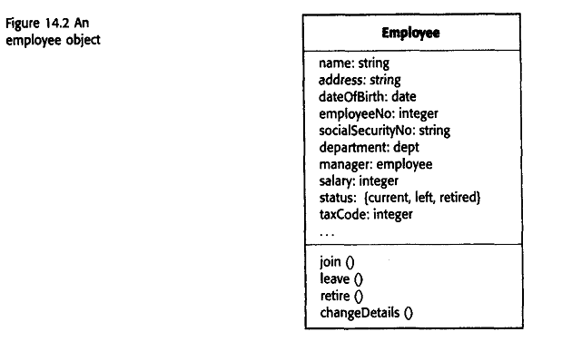
The ellipsis (...) indicates that there are more attributes associated with the class than are shown.
Object communication
Conceptually, objects communicate by message passing.
Messages
  - The name of the service requested by the calling object;
  - Copies of the information required to execute the service and the name of a holder for the result of the service.

Message examples
// Call a method associated with a buffer object that returns the next value in the buffer
v = circularBuffer.Get () ;
// Call the method associated with a thermostat object that sets the temperature to be maintained
thermostat.setTemp (20) ;
generalisation or inheritance hierarchy shows the relationship between object classes. Classes are arranged in a class hierarchy where one class (a super-class) is a generalisation of one or more other classes (sub-classes).A sub-class inherits the attributes and operations from its super class and may add new methods or attributes of its own.Generalisation in the UML is implemented as inheritance in OO programming languages.
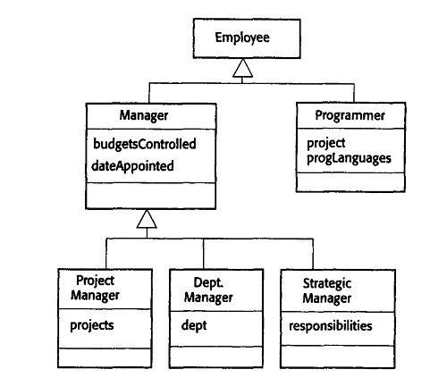
Problems with inheritance
Object classes are not self-contained. They cannot be understood without reference to their super-classes.
UML associations
Objects and object classes participate in relationships with other objects and object classes. Associations may be annotated with information that describes the association. Associations are general but may indicate that an attribute of an object is an associated object or that a method relies on an associated object.

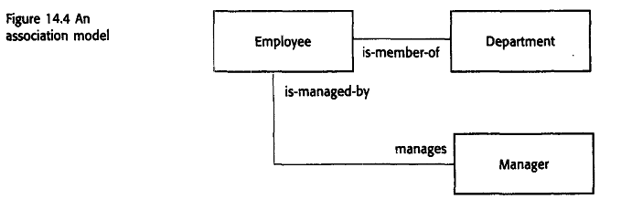
4.6.1 Concurrent Objects
In practice, most object-oriented programming languages have as their default a serial execution model where requests for object services are implemented in the same way as function calls. Therefore, when an object called theList is created from a normal object class, you write in Java:
theList.append (17)
This calls the append method associated with theList object to add the element 17 to theList, and execution of the calling object is suspended until the append operation has been completed. However, Java includes a very simple mechanism (threads) that lets you create objects that execute concurrently. Threads are created in Java by using the built-in Thread class as a parent class in a class declaration. Threads must include a method called run, which is started by the Java run-time system when objects that are defined as threads are created. It is therefore easy totake an object-oriented design and produce an implementation where the objects are concurrent processes.
TIlere are two kinds of concurrent object implementation:
1. Servers where the object is realized as a parallel process with methods corresponding to the defined object operations. Methods start up in response to an external message and may execute in parallel with methods associated with other objects. When they have completed their operation, the object suspends itself and waits for further requests for service.
2. Active objects where the state of the object may be changed by internal operations executing within the object itself. The process representing the object continually executes these operations so never suspends itself.
Servers are most useful in a distributed environment where the calling and the called object may execute on different computers. The response time for the service that is requested is unpredictable, system so the object that has requested a service does not have to wait for that service to be completed. They can also be used in a single machine where a service takes some time to complete (e.g., printing a document) and several objects may request the service.
Active objects are used when an object needs to update its own state at specified intervals. Figure 14.5 shows how an active object may be defined and implemented in Java.
The object class represents a transponder on an aircraft. The transponder keeps track of the aircraft's position using a satellite navigation system. It can respond to messages from air traffic control computers. It provides the current aircraft position in response to a request to the give Position method. This object is implemented as a thread where a continuous loop in the run method includes code to compute the aircraft's position using signals from satellites.
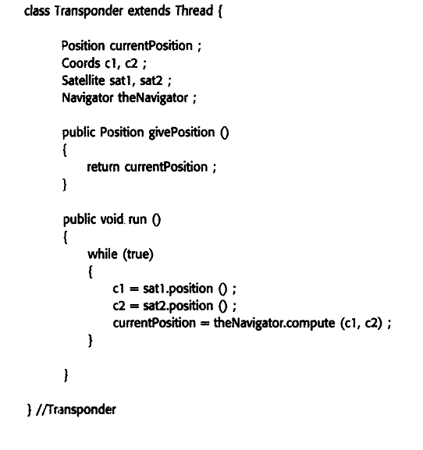
  - Object Oriented Design Process

The general process that is used for object-oriented design has a number of process stages:
  - Define the context and modes of use of the system;
  - Design the system architecture;
  - Identify the principal system objects;
  - Develop design models;
  - Specify object interfaces.
Weather station description (Let us consider this example for OOD)
A weather station is a package of software-controlled instruments, which collects data, performs some data processing and transmits this data for further processing. The instruments include air and ground thermometers, an anemometer, a wind vane, a barometer and a rain gauge. Data is collected periodically.
When a command is issued to transmit the weather data, the weather station processes and summarises the collected data. The summarised data is transmitted to the mapping computer when a request is received.
4.7.1System Context & models of use
The first stage in any software design process is to develop an understanding of the relationships between the software that is being designed and its external environment.
The system context and the model of system use represent two complementary models of the relationships between a system and its environment:
- The system context is a static model that describes the other systems in that environment. Use a subsystem model to show other systems.
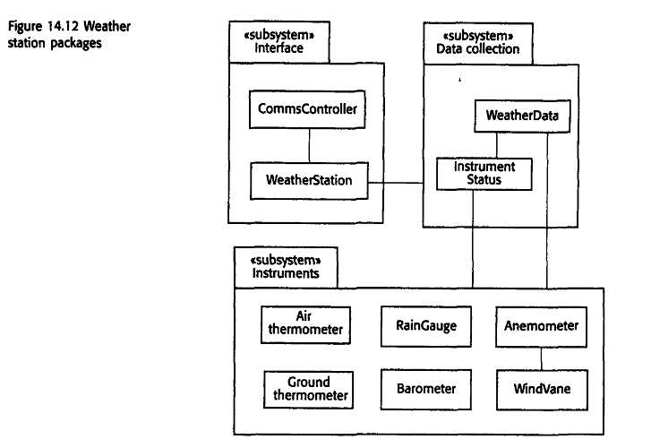

- The model of the system use is a dynamic model that describes how the system actually interacts with its environment. Use use-cases to show interactionsA use-case model shows the system features as ellipses and the interacting entity as a stick figure.
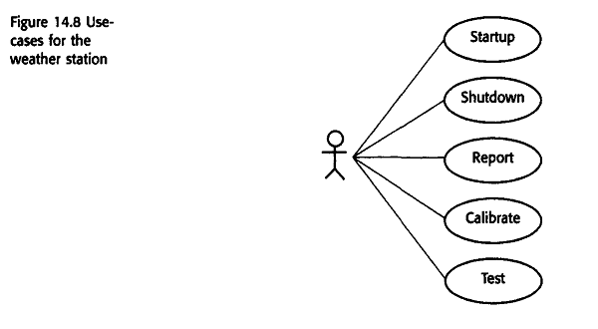
The use-case model for the weather station is shown in Figure 14.8. This shows that weather station interacts with external entities for startup and shutdown, for reporting the weather data that has been collected, and for instrument testing and calibration.
Each of these use-cases can be described in structured natural language. The use-case description helps to identify objects and operations in the system.
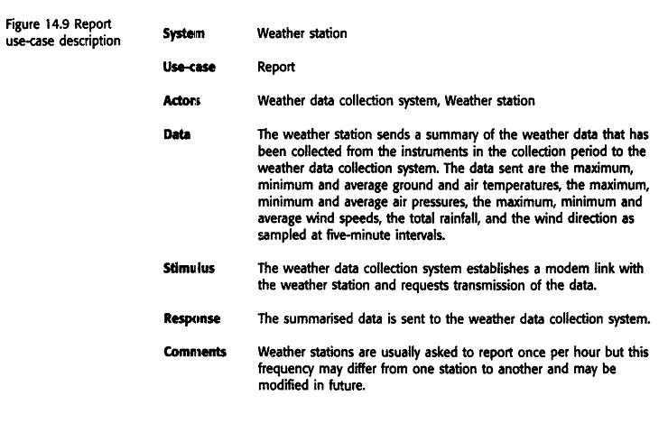
4.7.2 Architectural Design
Once interactions between the system and its environment have been understood, you use this information for designing the system architecture.
A layered architecture is appropriate for the weather station
  - Interface layer for handling communications;
  - Data collection layer for managing collection of data from instruments and summarising weather data before transmission to mapping system;
  - Instruments layer encapsulation of all instruments used to collect raw data.
Good rule of thumb is that there should normally be no more than 7 entities in an architectural model.
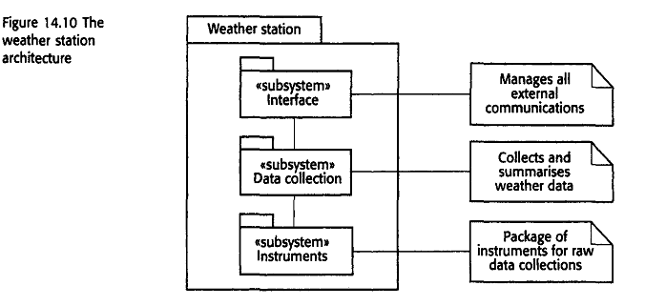
4.7.3 Object Identification
- Identifying objects (or object classes) is the most difficult part of object oriented design.
- There is no 'magic formula' for object identification. It relies on the skill, experience
and domain knowledge of system designers.
- Object identification is an iterative process. You are unlikely to get it right first time.
Approaches to identification
- Use a grammatical approach based on a natural language description of the system Objects and attributes are nouns; operations or services are verbs (used in Hood OOD method widely used in European aerospace industry).
- Base the identification on tangible things in the application domain. such as aircraft, roles such as manager, events such as request, interactions such as meetings, locations such as offices, organisational units such as companies, and so on.
- Use a behavioural approach and identify objects based on what participates in what behaviour.
- Use a scenario-based analysis. The objects, attributes and methods in each scenario are identified.
Weather station object classes
  - Ground thermometer, Anemometer, Barometer :Application domain objects that are ‘hardware’ objects related to the instruments in the system.
  - Weather station :The basic interface of the weather station to its environment. It therefore reflects the interactions identified in the use-case model.
Weather data : Encapsulates the summarised data from the instruments
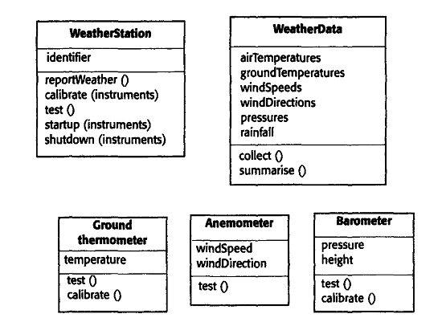
Fig: Examples of object classes in weather station system.
Further objects and object refinement
- Use domain knowledge to identify more objects and operations
  - Weather stations should have a unique identifier;
  - Weather stations are remotely situated so instrument failures have to be reported automatically. Therefore, attributes and operations for self-checking are required.
- Active or passive objects
  - In this case, objects are passive and collect data on request rather than autonomously. This introduces flexibility at the expense of controller processing time.
4.7.4 Design Models
Design models show the objects and object classes and relationships between these entities. Design models essentially are the design. They are the bridge between the requirements for the system and the syssstem implementation. An important step in the design process, therefore, is to decide which design models that you need and the level of detail of these models.
There are two types of design models that should normally be produced to describe an objen-oriented design:
- Static models describe the static structure of the system in terms of object classes and relationships.
- Dynamic models describe the dynamic interactions between objects
The UML provides for 12 different static and dynamic models that may be produced to document a design.
1. Subsystem models that show logical groupings of objects into coherent sub-systems. These are represented using a form of class diagram where each sub-system is shown as a package. Subsystem models are static models.
2. Sequence models that show the sequence of object interactions. These are represented using a UML sequence or a collaboration diagram. Sequence models are dynamic models.
3. State machine models that show how individual objects change their state in response to events. These are represented in the UML using state chart diagrams. State machine models are dynamic models.
Subsystem models
Shows how the design is organised into logically related groups of objects.In the UML, these are shown using packages - an encapsulation construct. This is a logical model. The actual organisation of objects in the system may be different

Sequence Models:
Sequence models show the sequence of object interactions that take place
  - Objects are arranged horizontally across the top;
  - Time is represented vertically so models are read top to bottom;
  - Interactions are represented by labelled arrows, Different styles of arrow represent different types of interaction;
  - A thin rectangle in an object lifeline represents the time when the object is the controlling object in the system.
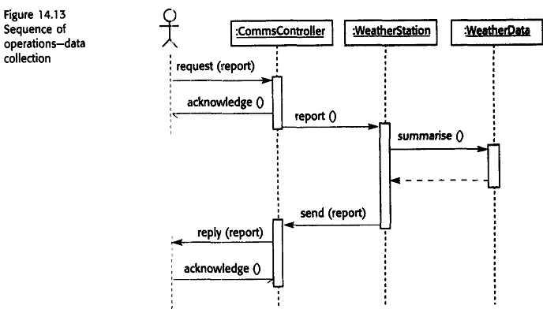
Statecharts
The UML uses statecharts, initially invented by Harel to describe state machine models.
Figure 14.14 is a statechart for the WeatherStation object that shows how it responds to requests for various services.
You can read this diagram as follows:
1. If the object state is Shutdown then it can only respond to a startupO message.It then moves into a state where it is waiting for further messages. The unlabelled arrow with the black blob indicates that the Shutdown state is the initial state.
2. In the Waiting state, the system expects further messages. If a shutdownO message is received, the object returns to the shutdown state.
3. If a reportWeatherO message is received, the system moves to the Summarising state. When the summary is complete, the system moves to a Transmitting state where the information is transmitted through the CommsController. It then returns to the Waiting state.
4. If a calibrateO message is received, the system moves to the Calibrating state, then the Testing state, and then the Transmitting state, before returning to the Waiting state If atestO message is received, the system moves directly to the Testing state.
5. If a signal from the clock is received, the system moves to the Collecting state, where it is collecting data from the instruments. Each instrument is instructed in turn to collect its data.
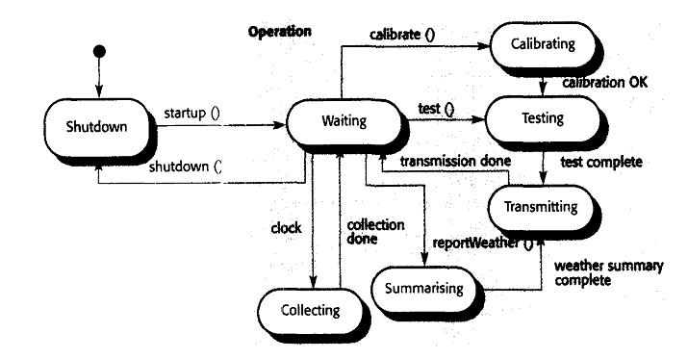
Fig: State Diagram For weather station
Object Interface Specification
- Object interfaces have to be specified so that the objects and subsystems can be designed in parallel.
- Designers should avoid designing the interface representation but should hide this in the object itself.
- Objects may have several interfaces, which are viewpoints on the methods provided.
- The UML uses class diagrams for interface specification but Java may also be used.
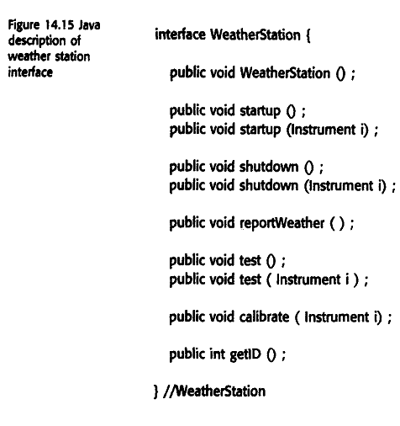
The Java description can show that some methods can take different numbers of parameters. Therefore, the shutdown method can be applied either to the station as a whole if it has no parameters or to a single instrument.
  - Design Evolution

- Hiding information inside objects means that changes made to an object do not affect other objects in an unpredictable way.
- Assume pollution-monitoring facilities are to be added to weather stations. These sample the air and compute the amount of different pollutants in the atmosphere. Pollution readings are transmitted with weather data.
Changes required
- Add an object class called Air quality as part of WeatherStation.
- Add an operation reportAirQuality to WeatherStation. Modify the control software to collect pollution readings.
- Add objects representing pollution monitoring instruments.
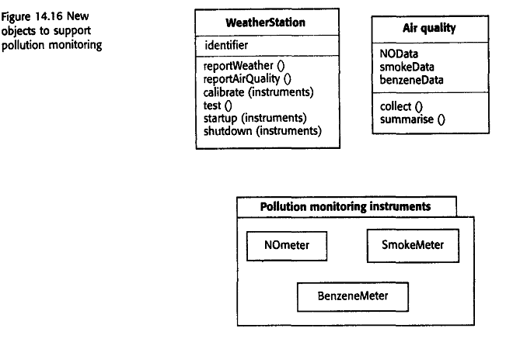

s

